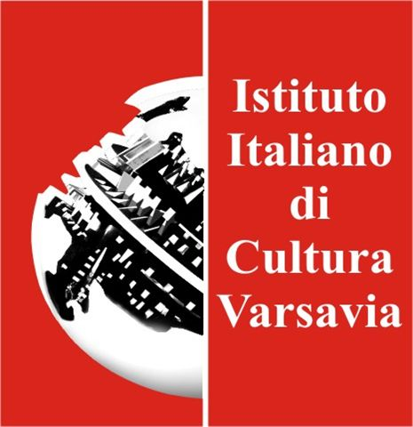
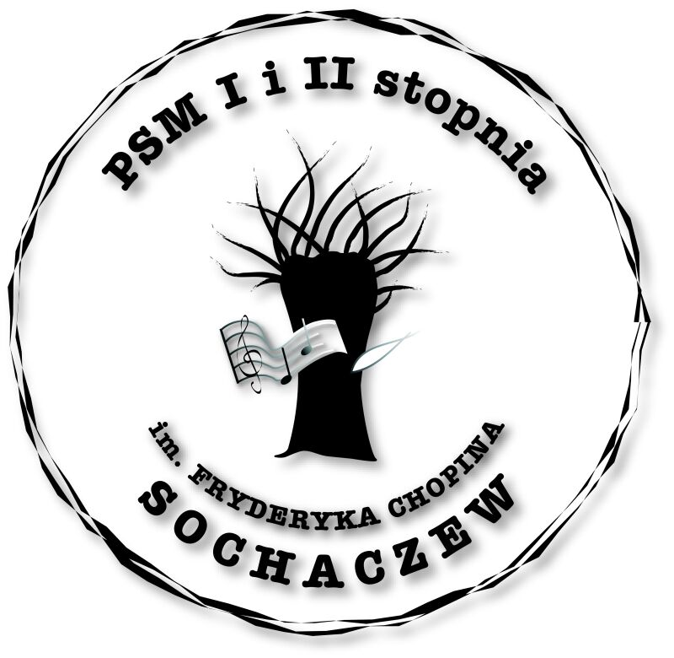



The Municipal Culture Center in Sochaczew

Fryderyk Chopin State Music School in Sochaczew
Italian Institute of Culture in Warsaw

19th INTERNATIONAL CHOPIN FESTIVAL
IN MAZOVIA
POLAND

SOCHACZEW 15 - 20 October 2011

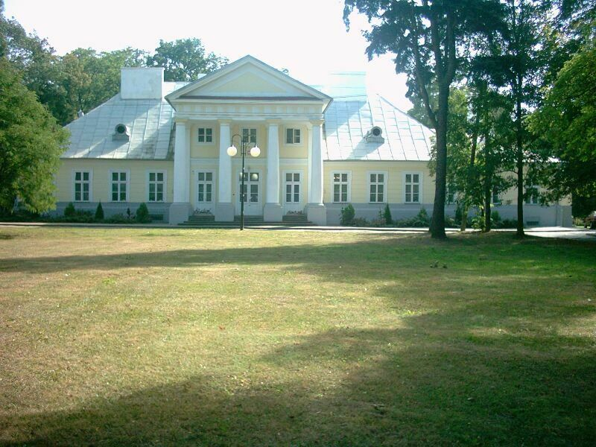

Jury members of the 19th International Chopin Festival in Mazovia
in alphabetical order:

Jan Kadłubiski Fryderyk Chopin University of Music in Warsaw-

(Chairman)

Dorian Leljak Academy of Arts – Serbia

Pierpaolo Levi Accademia di Musica Ars Nova – Trieste

Jerzy Sterczyński Fryderyk Chopin University of Music in Warsaw

Anton Voigt Anton Bruckner Privatuniversitaet - Lin

15 October 2011 (Saturday) 4h.p.m.

GALA OPENING OF THE XIXth INTERNATIONAL
CHOPIN FESTIVAL IN MAZOVIA

15 – 16 X 2011 Piano recitals of the Jury members at the Concert Hall
of the Fryderyk Chopin Music School in Sochaczew

17. X. 2011 10.00a.m. Public Audition for Participants

18.X.2011 10.00a.m. Public Audition for Participants

19.X.2011 10.00a.m. Public Audition for Participants

3p.m. Announcement of the Prize -Winners
Meeting of the Teachers of the Participants with
the members of the International Jury

19.X.2011 5p.m. CONCERT HALL

AWARD CEREMONY - GALA CONCERT GIVEN BY
THE PRIZE –WINNERS OF THE XIXth INTERNATIONAL
CHOPIN FESTIVAL IN MAZOVIA

20.X.2011 Concerts given by the prize winners in prestigious
Concert Halls of Warsaw

The following are the organizers of the XIXth International Chopin Festival in Mazovia:
Municipal Center of Culture in Sochaczew – Director Halina Pędziejewska
Fryderyk Chopin State Music School - Director Joanna Niewiadomska-Kocik
We want to give the young artists an opportunity to appear on the stage in our school located near the Birth Place of Frederic Chopin in Żelazowa Wola – a place revered by the entire World.
We also want to offer the participants a chance to visit the House of Fryderyk Chopin in Żelazowa Wola.
The International Jury will assess the participants’ Artistic Merit, without the use of comparison scale, and select over ten people to participate in the Gala Concert of the Prize -Winners.
The Jury decision will be final. There will be no appeal from their verdict.
All of the Prize – Winners will be obliged to take part in the Gala Concert as well as they will be honored to participate in prestigious concerts at the Concert Halls of Warsaw on 20th October 2011.

REGULATIONS

The young artists had to prepare for an audition the programme containing Bach and Chopin's works.
There is no dividing the participants into age groups. Instead of that, they could prepare for an audition the programme chosen from one of the three repertoires showing their advanced level:

I repertoire
J.S. Bach - One of the Menuet from “Notebook for Anna Magdalena Bach”
F. Chopin - One of the three early Polonaises in G minor -1817, in B flat major - 1817
in A flat major - 1821
Special Award for the best performance of the Polonaise in A flat major

II repertoire
J. S. Bach - one of the Inventions “a 2 voci” or
F. Chopin – Fugue in A minor (Ed. I.J. Paderewski, “Minor Works”)
Special Award for the best performance of the F. Chopin’s Fugue in A minor

F. Chopin - one of the following works (Ed. I.J.Paderewski, “Minor Works”):
Nocturne in C minor
Nocturne in C sharp-minor
Contredanse
Cantabile
Largo
Waltz in A minor, op. posthumous
(Ed. PWM, “Two forgotten Waltzes”)
Waltz in E major, op. posthumous
(Ed. PWM, “ Two forgotten Waltzes”)
Feuille D’Album

III repertoire
J.S. Bach - Prelude and Fugue from the 1st or 2 nd volume of DWK Ed. URTEXT
F. Chopin - 2 different works from the following:
Waltzes
Nocturnes
Impromptus
3 Écossaises op. 72
Polonaises
(excluding the early and the 4 great Polonaises
op. 22, op. 53, op. 44, op. 61)
Mazurkas
Rondo in C minor, op. 1
Etudes op. 10, op. 25
3 Études from Méthodes des Méthodes (Trois Nouvelles Etudes)

All the participants have to performe their repertoires by heart

1. All participants will get Honourable Diploma.
2. The Lauraets will get awards during the Gala Concert of the Prize -Winners.
3. The programme of Gala Concert of the Prize-Winners will be settled by Jury
4. All of the Prize – Winners will be obliged to take part in the Gala Concert
as well as they will be honored to participate in prestigious concerts at
the Concert Halls of Warsaw on 20 th October 2011.
5. Meeting of the Teachers of the Participants with members of the
International Jury will be possible after auditions of the all participants
- Jury will select participants after listening all repertoire groups
7. The list of admitted participants will be available on the website www.festiwal.vin.pl
after 10 October 2011.
8. Rehearsals will take place on 17th – 19 th October 2011
(after making a phone appointment with the organizer )
9. All details connected with the Festival will be posted on our website:
www.festiwal.vin.pl , www.muzyczna.e-sochaczew.pl
or phones: tel./fax – 48 46 862 29 62
mobile phone +48 501666884, +48 604469391
10. All of the participants must be ready one hour before their scheduled recitals.
11. Organizer secure the lunch for the participant in the public audition day
12. Participants' auditions and Prize-Winners Concerts can be transmitted on
the radio and TV as well the photos can be taken for the purpose of the Press
and the Festival promotion.
13. The participants are responsible for their own travel and accommodation costs.

Please send the application form(available on our website www.festival.vin.pl
and the fee of 40 Euros paid by bank transfer to the bank account:

PL 82 9283 0006 0013 2352 2000 0020 (SFIFT – POLUPLPR)
before 07 October 2011 to the following address:
Państwowa Szkoła Muzyczna I i II st. im. Fr. Chopina
96-500 Sochaczew, ul. Głowackiego 2. POLAND
or to the following e-mail: psmsochaczew@pro.onet.pl

in the event of cancellation fee is not refundable

For those participants and their guardians, who would like to stay
in Sochaczew overnight, we list the following hotels where reservation
can be made:
- Hotel “Kameralna” Phone +48 885 674 332 www.kameralna.eu
- Hotel „Chopin” Phone. (48 46) 862-59-99 www.hotelchopin.p
- Hotel Garnizonowy Phone (48 46) 864-33-15
- Centrum Kształcenia Kadr in Teresin - (48 46) 861-37-69

